# **GitLab Installation on Ubuntu**

Installing GitLab on Ubuntu involves a series of steps. Here's a step-by-step guide to help you through the process:

**Step 1: Launch an EC2 Instance**

Choose required number of resources to install and run GitLab on the EC2 instance.

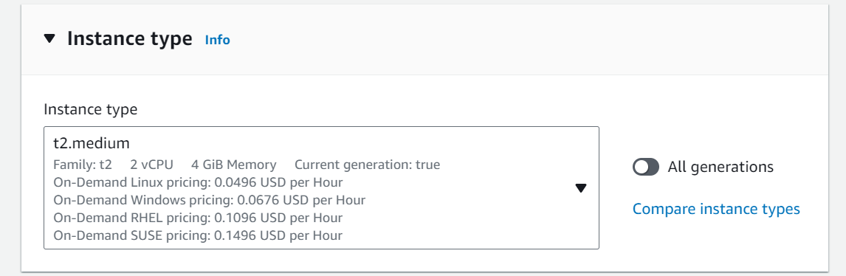

General recommendations for CPU and memory when installing GitLab on an EC2 instance:

* **Small Team (Up to 100 users, few projects, light activity):**
  + CPU: 2 vCPUs
  + Memory: 4 GB RAM
* **Medium Team (Up to 500 users, moderate projects, activity):**
  + CPU: 4 vCPUs
  + Memory: 8 GB RAM
* **Large Team (Up to 1000 users, many projects, high activity):**
  + CPU: 8 vCPUs
  + Memory: 16 GB RAM

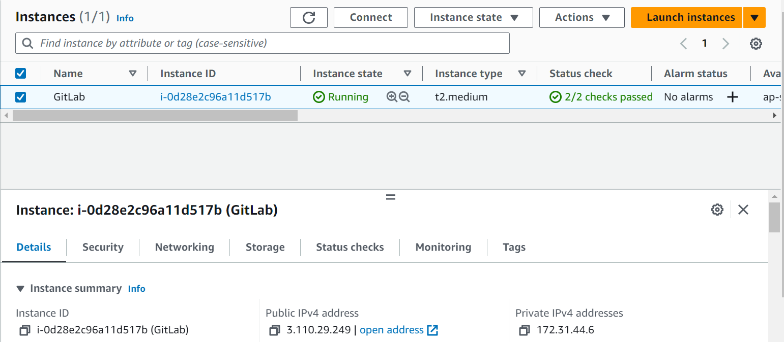

**Step 2: Connect the EC2 instance**

Use Putty to connect the instance using ppk key file.

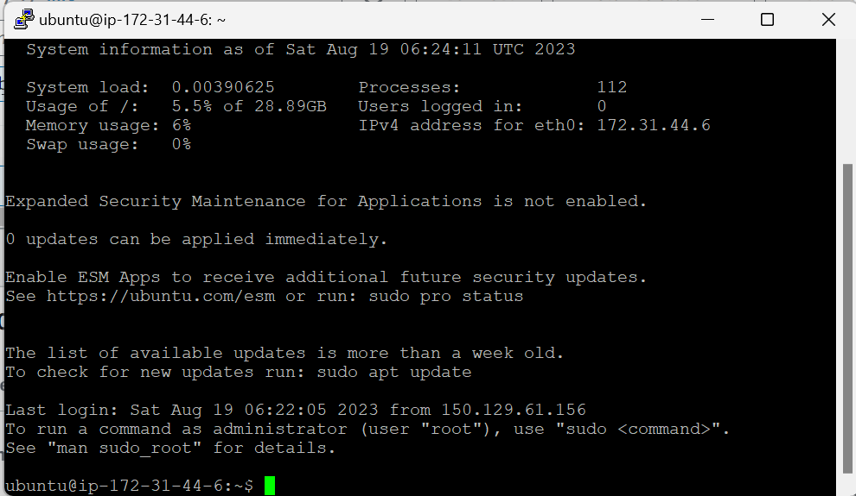

**Step 3: Update your system**

Ensure your system is up to date by running the following commands:

sudo apt update

sudo apt upgrade

**Step 4: Install Required Dependencies**

Install the required dependencies such as Postfix (for sending emails), curl, and other necessary packages:

sudo apt install curl openssh-server ca-certificates postfix

**Step 5: Install GitLab** Now, you can install GitLab using the official GitLab package repository. Run the following commands:

curl -sS https://packages.gitlab.com/install/repositories/gitlab/gitlab-ce/script.deb.sh | sudo bash

sudo apt install gitlab-ce

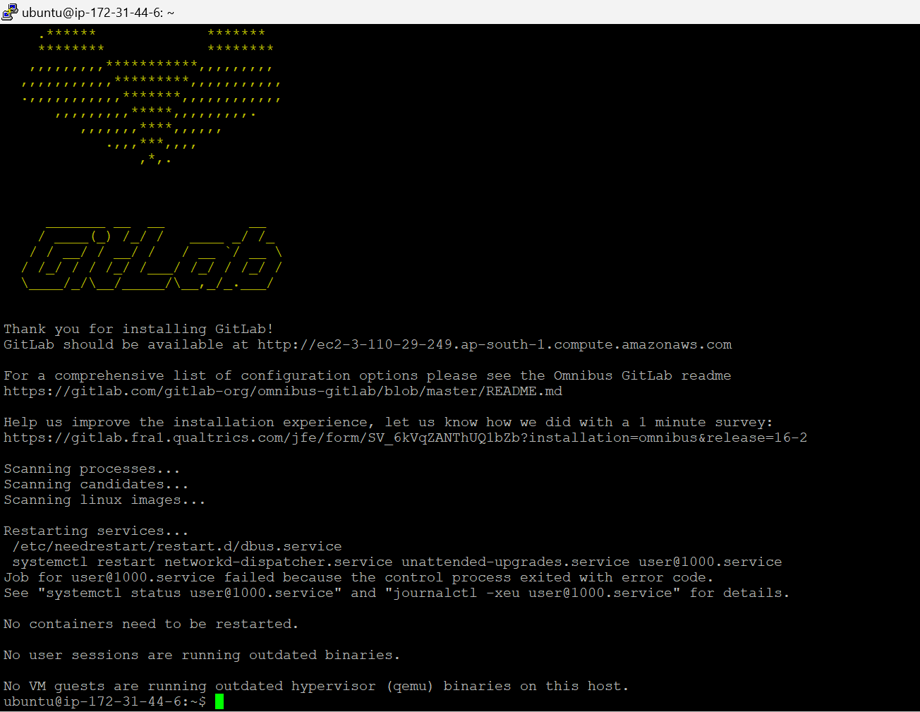

**Step 6: Configure GitLab**

Edit the GitLab configuration file to set up the URL and other settings

sudo nano /etc/gitlab/gitlab.rb

Find the **‘external_url’** line and replace it with your server's URL:

i.e., external_url 'https://gitlab.insigniaconsultancy.com'

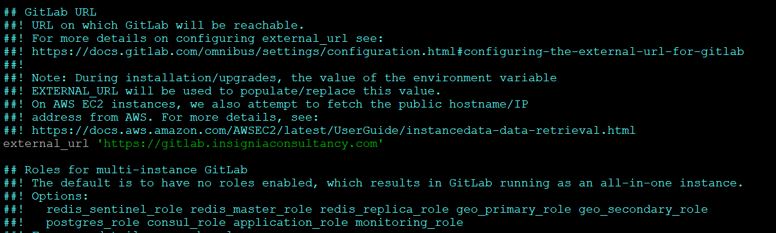

Save the file and exit the text editor.

**Step 7: Start GitLab**

After configuring GitLab, reconfigure it and start the services:

sudo gitlab-ctl reconfigure

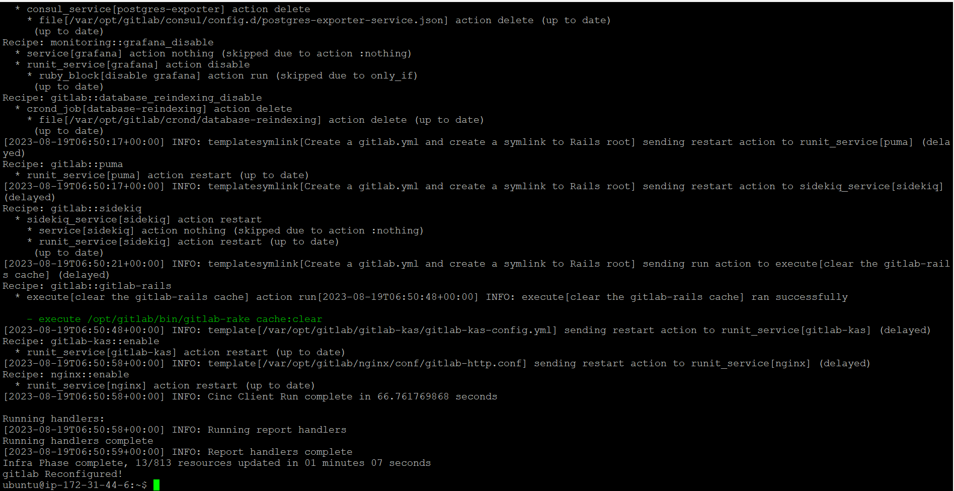

**Step 8: Firewall Configuration**

If you have a firewall enabled, make sure to open the necessary ports for GitLab:

sudo ufw allow OpenSSH

sudo ufw allow http

sudo ufw allow https

sudo ufw enable

**Step 9: Access GitLab Web Interface**

Once the reconfiguration is complete, you can access the GitLab web interface using a web browser. Navigate to the URL that matches the external URL you specified in the configuration file.

**Step 10: Set Up Your Administrator Password**

During your first visit to the GitLab web interface, you'll be prompted to set up an administrator password.

